SANSKAAR PATNI
180905134 CSE-C 23
OS LAB 5

1. Producer Consumer using FIFO queue
Set of 4 integers

//producer.c
#include <stdio.h>
#include <string.h>
#include <fcntl.h>
#include <sys/stat.h>
#include <sys/types.h>
#include <unistd.h>
#include<stdlib.h>
#define FIFO_NAME "/home/student/180905134/OS/Lab5/fifoFirst"
int main()
{
int fd;
char arr[80];
int num=0;
char numString[5];
int res;
if (access(FIFO_NAME, F_OK) == -1)
{
res = mkfifo(FIFO_NAME, 0777);
if (res != 0)
{
fprintf(stderr, "Could not create fifo");
exit(EXIT_FAILURE);
}
}
fd = open(FIFO_NAME, O_WRONLY);
if (fd != -1)
{
while (1)
{
printf("Enter set of 4 integers\n");
for(int i=0;i<4;i++){
scanf("%d",&num);
sprintf(numString,"%d",num);
strncat(arr," ",1);
strcat(arr,numString);
}
write(fd, arr, strlen(arr)+1);
arr[0]='\0';
}
close(fd);
}
else{
exit(EXIT_FAILURE);
}
printf("Process %d finished\n", getpid());
exit(EXIT_SUCCESS);
}

//consumer.c
#include <stdio.h>
#include <string.h>
#include <fcntl.h>
#include <sys/stat.h>
#include <sys/types.h>
#include <unistd.h>
#include<stdlib.h>
#define FIFO_NAME "/home/student/180905134/OS/Lab5/fifoFirst"
int main()
{
int fd1;
// mkfifo(FIFO_NAME, 0666);
char str[80];
int res;
fd1 = open(FIFO_NAME,O_RDONLY);
if(fd1!= -1){
res=read(fd1, str, 80);
do
{
printf("Producer sent %s\n", str);
res=read(fd1, str, 80);
} while(res>0);
close(fd1);
}
else
{
exit(EXIT_FAILURE);
}
printf("Process %d finished\n", getpid());
exit(EXIT_SUCCESS);
}

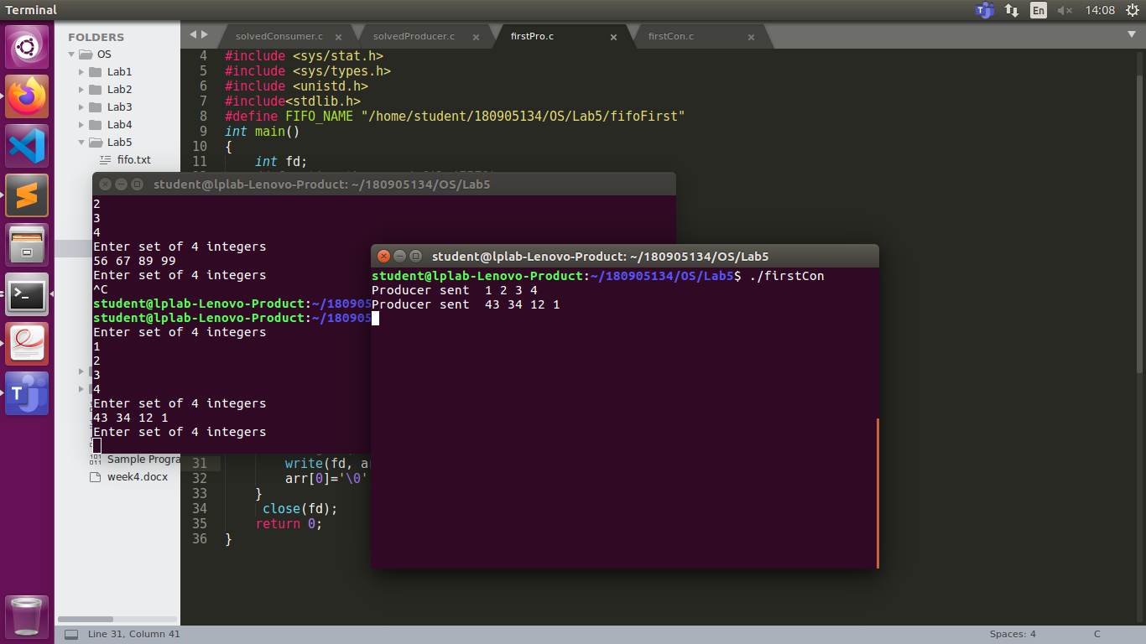

2.Pipe
#include <stdlib.h>
#include <stdio.h>
#include <string.h>

int main(int argc, char *argv[])
{
int n;
int fd[2];
char buf[1025];
char *data = "hello..This is sample data";
pipe(fd);
write(fd[1], data, strlen(data));
if ((n = read(fd[0], buf, 1024)) >= 0)
{
buf[n] = 0; //terminate string
printf("read %d bytes from the pipe:\"%s\"\n", n, buf);
}
else
perror("read");
exit(0);
}
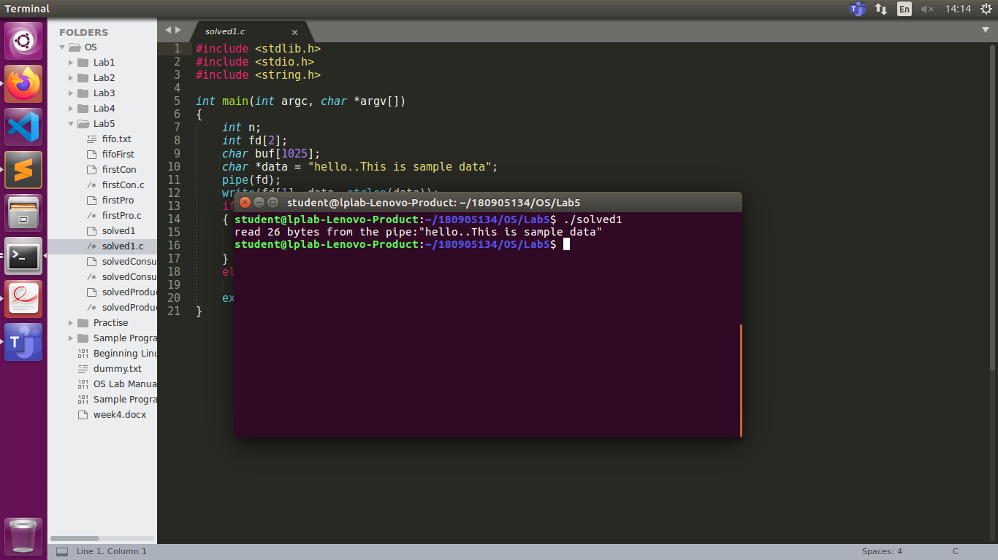
3. One side of FIFO
#include <stdio.h>
#include <string.h>
#include <fcntl.h>
#include <sys/stat.h>
#include <sys/types.h>
#include <unistd.h>
#include<stdlib.h>
int main()
{
int fd;
char * myfifo = "/home/student/180905134/OS/Lab5/fifoSecond";
mkfifo(myfifo, 0666);

char arr1[80], arr2[80];
while (1)
{
fd = open(myfifo, O_WRONLY);
if(fd!=-1) {
fgets(arr2, 80, stdin);
write(fd, arr2, strlen(arr2)+1);
arr2[0]='\0';
close(fd);
}
else{
exit(EXIT_FAILURE);
}
fd = open(myfifo, O_RDONLY);
if(fd!=-1) {
read(fd, arr1, sizeof(arr1));
printf("User2: %s\n", arr1);
arr1[0]='\0';
close(fd);
}
else{
exit(EXIT_FAILURE);
}
}
return 0;
}

#include <stdio.h>
#include <string.h>
#include <fcntl.h>
#include <sys/stat.h>
#include <sys/types.h>
#include <unistd.h>
#include<stdlib.h>
int main()
{
int fd1;
char * myfifo = "/home/student/180905134/OS/Lab5/fifoSecond";
mkfifo(myfifo, 0666);
char str1[80], str2[80];
while (1)
{
fd1 = open(myfifo,O_RDONLY);
if(fd1!=-1) {
read(fd1, str1, 80);
printf("User1: %s\n", str1);
str1[0]='\0';
close(fd1);
}
else
{
exit(EXIT_FAILURE);
}
fd1 = open(myfifo,O_WRONLY);
if(fd1!=-1) {
fgets(str2, 80, stdin);
write(fd1, str2, strlen(str2)+1);
str2[0]='\0';
close(fd1);
}
else
{
exit(EXIT_FAILURE);
}
}
return 0;
}

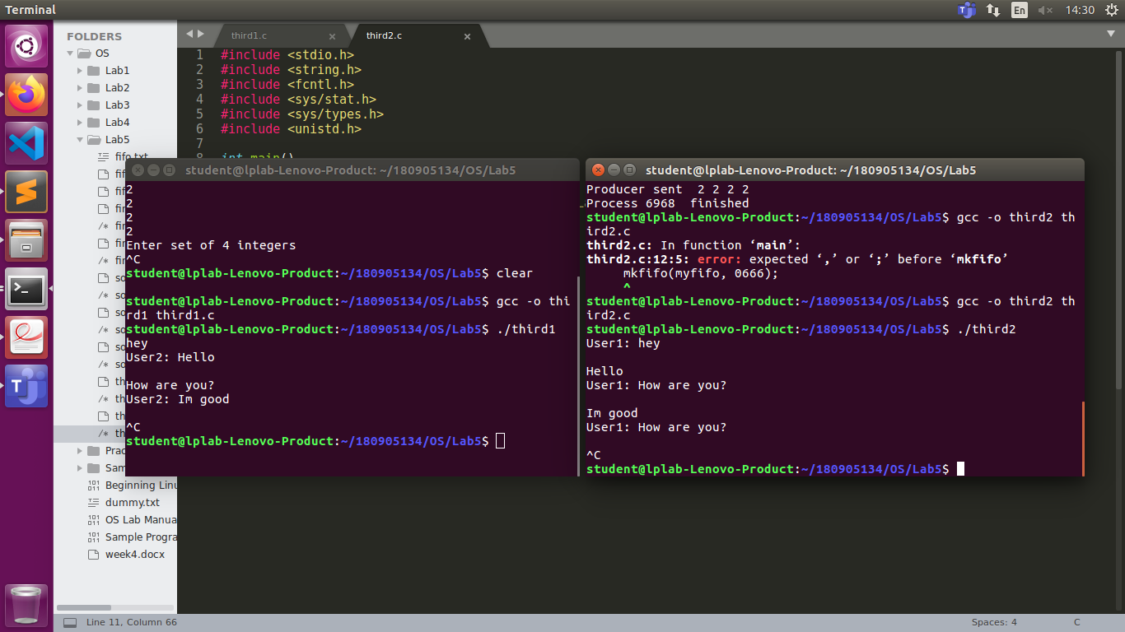

4.Binary Files
#include <stdio.h>
#include <stdlib.h>

int main()
{
FILE *fptr;
int num;
int num1=0;
fptr = fopen("example.bin","wb+");
printf("Enter 4 binary numbers\n");
for(int i=1;i<=4;i++)
{
scanf("%d",&num);
fwrite(&num, sizeof(int), 1, fptr);
}
printf("Write finished!! \n");
fclose(fptr);
fptr = fopen("example.bin","rb");
for(int i=1;i<=4;i++)
{
fread(&num1, sizeof(int), 1, fptr);
printf("%d\n",num1);
}
printf("Read finished!! \n");
}

